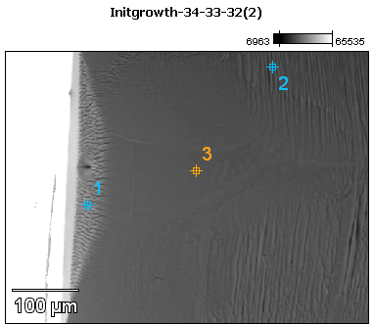

Image Name: Initgrowth-34-33-32(2)

Image Resolution: 512 by 384

Image Pixel Size: 1.08 µm

Acc. Voltage: 12.0 kV

Magnification: 230

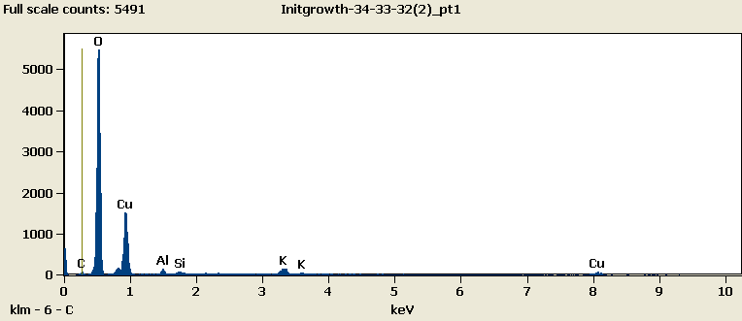

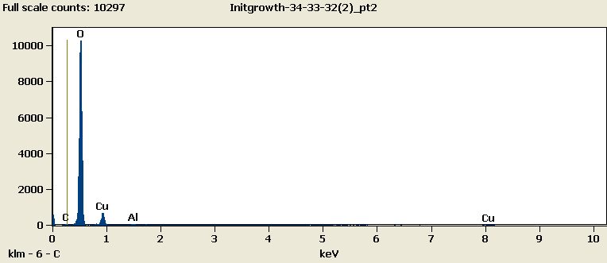

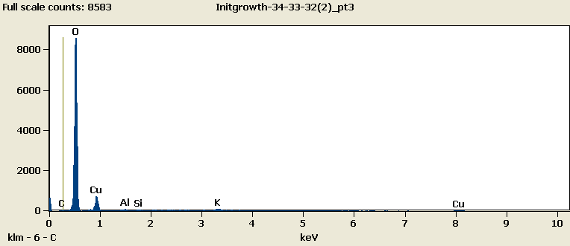

Weight %

|  |
| --- |
| ***Initgrowth-34-33-32(2)_pt1-No Data.*** |
| ***Initgrowth-34-33-32(2)_pt2-No Data.*** |
| ***Initgrowth-34-33-32(2)_pt3-No Data.*** |

Weight % Error (+/- 1 Sigma)

|  |
| --- |
| ***Initgrowth-34-33-32(2)_pt1-No Data.*** |
| ***Initgrowth-34-33-32(2)_pt2-No Data.*** |
| ***Initgrowth-34-33-32(2)_pt3-No Data.*** |

# Cations

|  |
| --- |
| ***Initgrowth-34-33-32(2)_pt1-No Data.*** |
| ***Initgrowth-34-33-32(2)_pt2-No Data.*** |
| ***Initgrowth-34-33-32(2)_pt3-No Data.*** |